**Oasis Space Bar: Booking and Reservation for Luxury Resorts**



College of Computer and Information Science

Mapua Malayan Colleges Mindanao

Gen. Douglas McArthur Hwy, Talomo,

Davao City, 8000 Davao del Sur

_____________________

A Project by Triple J Royals:

Jonreff Maxey Gamao  
Luan Sebastian Jardin  
Jess Luengas

### **Chapter I**

### **Introduction**

**Background of the Study**

The luxury resort industry faces significant challenges with its existing booking systems, which can be broadly categorized into manual and potential automated systems. Manual systems rely on in-person interactions, offering personalized service but often resulting in time-consuming processes and errors. Automated systems, while more efficient, can lead to user confusion and a perceived lack of personal touch. The need for a streamlined, user-friendly booking system that combines the best of both approaches has led to the development of Oasis Spacebar, a mobile application designed to simplify and enhance the reservation process for luxury resort stays.

#### **Statement of the Problem**

The current booking systems for luxury resorts like Oasis Spacebar face several issues:

1. There is a significant time delay in searching for available rooms or spaces.
2. Users need help navigating through complex and cluttered interfaces.
3. Inconsistent terminology within the system causes confusion.
4. Customizable search options are necessary to maintain efficiency.
5. Users are not provided a comprehensive summary before finalizing their bookings, leading to errors.

#### **Assumption of the Study**

The proposed Oasis Spacebar application aims to solve the identified problems through the following features:

* An intuitive, streamlined interface to reduce search and booking times.
* Consistent and user-friendly terminology throughout the app.
* Customizable search filters to enhance user control and efficiency.
* A summary page providing an overview of the booking before final submission.
* Improved error prevention and detailed error messages to guide users. These features are designed to address the deficiencies in the current system effectively

#### **Significance of the Study**

The proposed Oasis Spacebar system will benefit various stakeholders:

* **Users**: They will experience a seamless and efficient booking process, reducing frustration and saving time. Enhanced user satisfaction can lead to increased loyalty and repeat bookings.
* **Leisure Space Providers**: They can expect higher occupancy rates and improved customer satisfaction due to the streamlined booking process. This can lead to better resource management and increased revenue.
* **Developers**: The design is a model for creating user-friendly applications, providing a framework for future projects. Developers gain insights into best practices for blending automated efficiency with personalized service.
* **Administrators**: Reducing booking complexity and time allows them to focus on other critical tasks, enhancing overall operational efficiency. Improved data accuracy and reduced manual workload are additional benefits.

**Chapter II**

**Research Design**

#### **User-Centered System Design Process**

The design process model used for developing Oasis Spacebar consists of several key stages:

1. **Task Analysis**

A hierarchical task analysis of the proposed design was conducted to identify each step users must take to complete a booking. This analysis ensures the design addresses all user needs effectively. By breaking down the booking process into detailed tasks, we can pinpoint specific areas for improvement and ensure that the system supports users at every stage. This method helps in understanding user behavior, identifying potential pain points, and creating a more intuitive interface.

1. **Requirements Gathering**

To gather the necessary data for the proposal, the following methods were utilized:

* **Survey via Google Forms:** Distributed to a broad audience to gather quantitative data on user preferences and issues.
* **Heuristic Evaluation:** Conducted based on Nielsen's 10 heuristic principles to identify usability issues.
* **5E's Evaluation:** Assessed the app's effectiveness, efficiency, engagement, error tolerance, and ease of learning.

The requirements were categorized as follows:

* **User Requirements**: Ease of use, intuitive navigation, and quick booking process. Users expressed a strong preference for a streamlined and hassle-free experience.
* **Functional Requirements**: Search filters, booking summary, and error prevention mechanisms. These features are essential for enhancing the usability and reliability of the application.
* **Data Requirements**: Secure storage of user data and booking information. Ensuring data privacy and security is crucial to gaining user trust.
* **Environmental Requirements**: Compatibility with various devices and operating systems. The application must perform well across different platforms to cater to a broad user base.
* **Usability Requirements**: Clear instructions, consistent terminology, and accessible help resources. These elements are vital for creating an inclusive and user-friendly application.

1. **Storyboarding and Prototyping**

A storyboard illustrating the entire user journey within the app was created. This visual representation helps in mapping out the flow of interactions and identifying potential issues early in the design process. The prototype of Oasis Spacebar includes input and output forms, described in a user manual detailing their functions and how users interact with the system. This step is crucial for validating design choices and gathering user feedback before full-scale development.

**Storyboard**  
  
**Scenario 1:** The girl was bored during the summer when suddenly her phone dinged with a notification about an ad for Oasis Spacebar. She wanted to go but was worried the rooms might be full. Luckily, she discovered that reservations were available.  
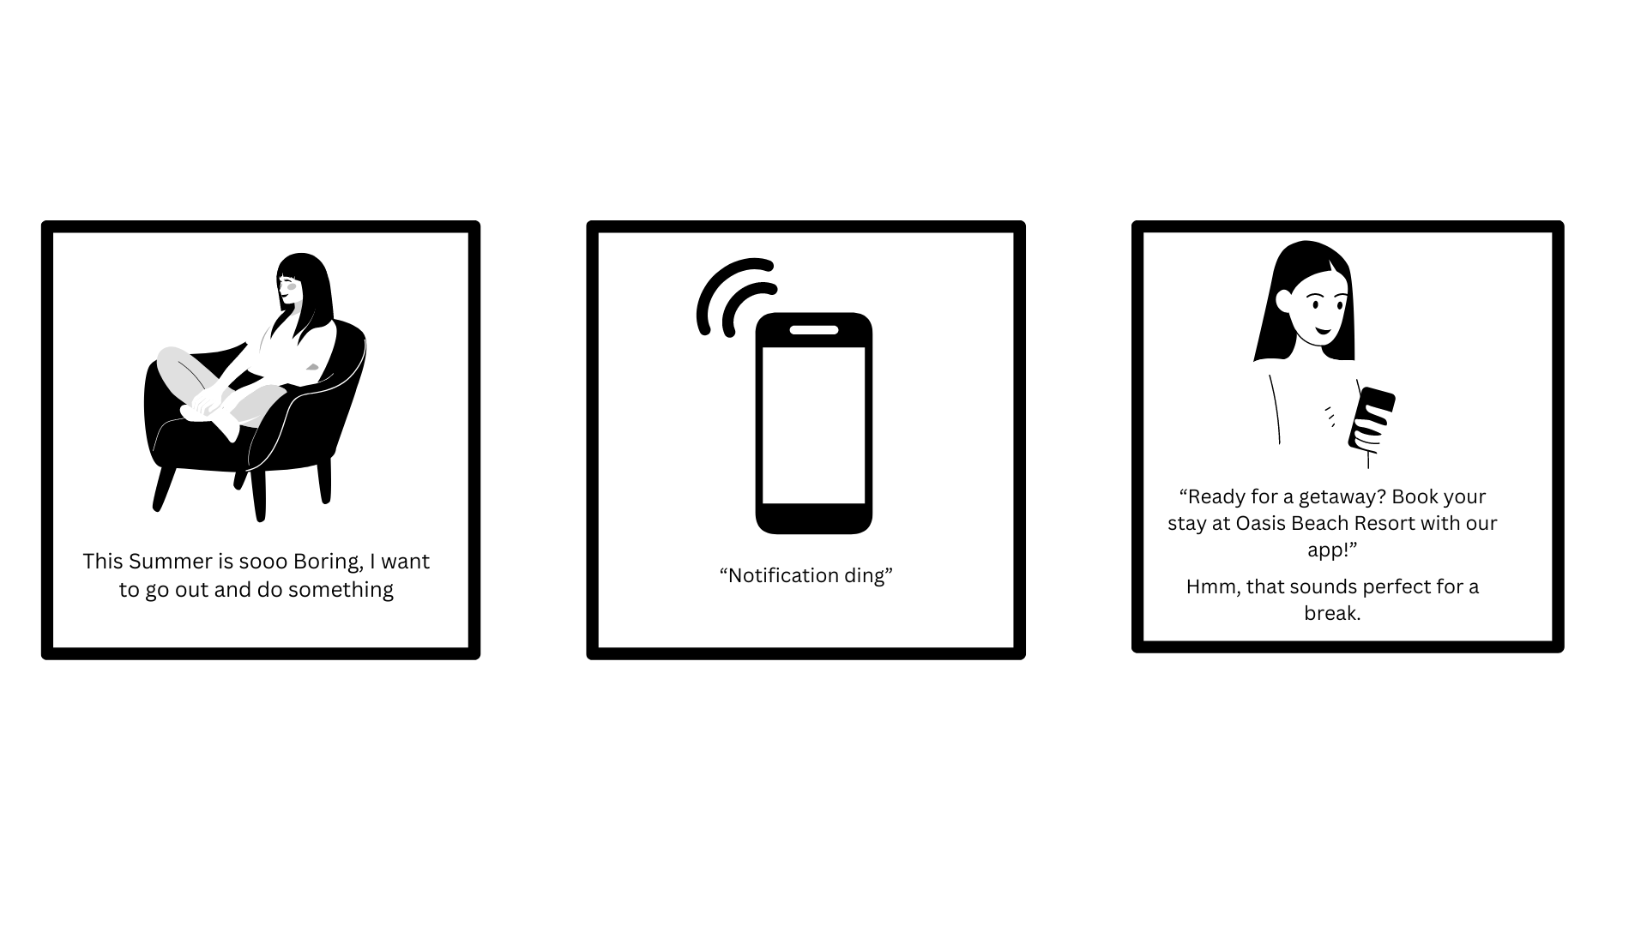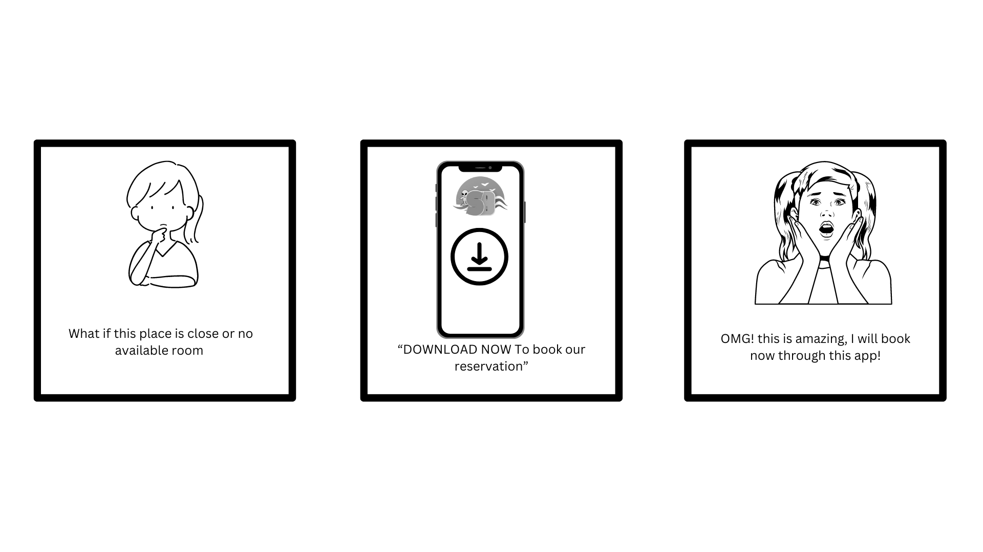

**Scenario 2:** In a class, the students were excited for summer break but also worried it might be boring. Someone suggested going to the beach, but another pointed out that it could be problematic since there were so many of them. Then, someone mentioned knowing a place where you can reserve a beach using a mobile app, and everyone rejoiced.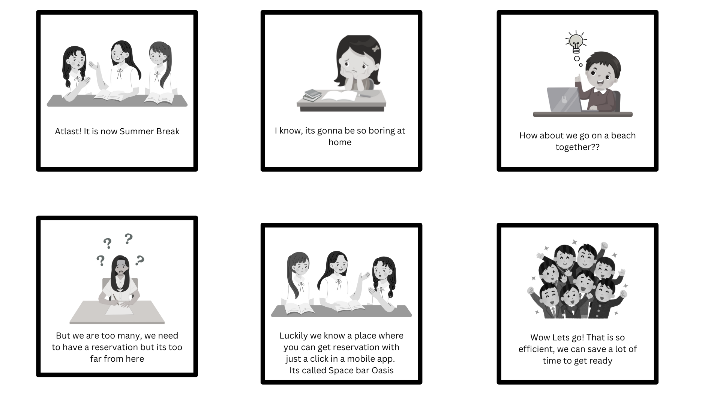**Scenario 3:** A man was very stressed at work. While scrolling through social media, he saw an ad for Oasis Spacebar and noticed many people having fun. He then downloaded the app to make a reservation.

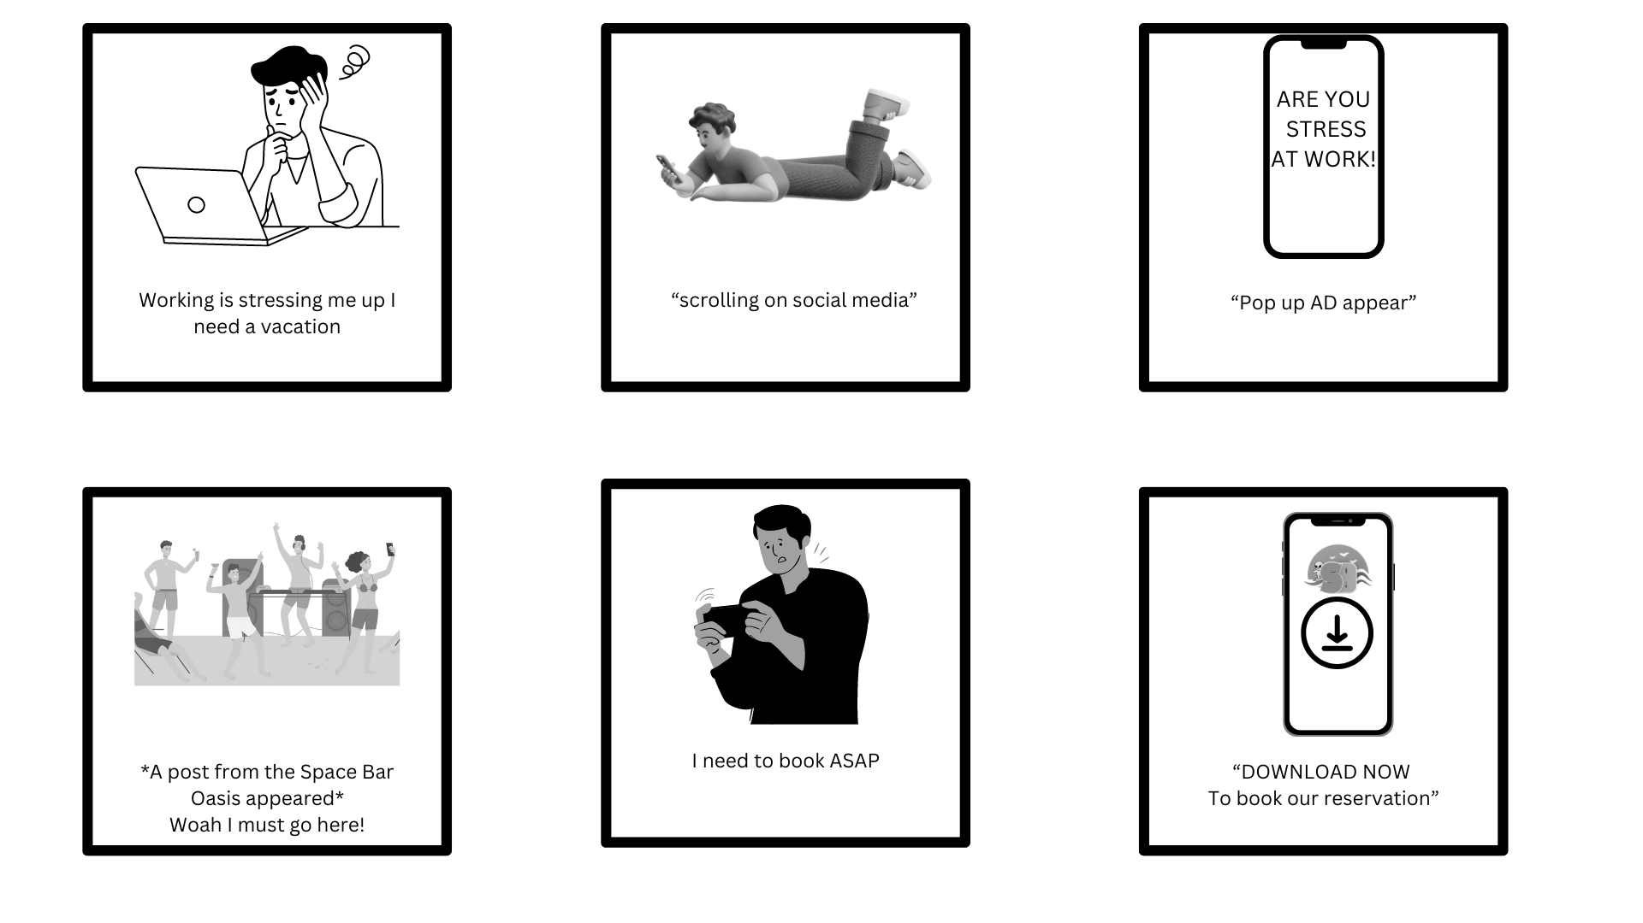

1. **Evaluation of Prototype**

Evaluation Criteria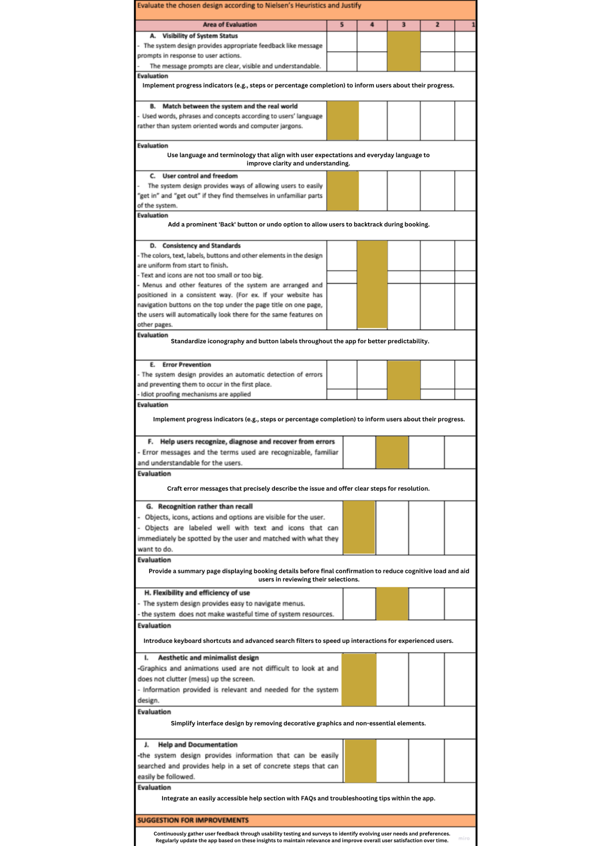

**Chapter III  
Conclusion and Recommendation**

The evaluation of the Oasis Spacebar mobile application has provided valuable insights into enhancing both user experience and operational efficiency. To improve usability, it is crucial to standardize icons and terminology across the interface, ensuring consistency and simplifying navigation. Visual clarity in critical sections such as booking details and payment processes should be enhanced to facilitate user comprehension. Implementing interactive onboarding features like tooltips and guided tours will aid new users in navigating the app effectively, while personalized functionalities such as saved preferences can enhance user engagement. Accessibility remains a priority, necessitating compliance with WCAG guidelines and comprehensive testing to ensure inclusivity for all users.

Performance optimization efforts should focus on reducing load times and improving stability, particularly for users on slower networks. Strengthening data security through enhanced encryption and regular audits is essential to protect user information. Continuous feedback mechanisms, including in-app surveys, will provide ongoing insights for iterative improvements aligned with evolving user needs. Finally, preparing for global readiness involves considering localization and integration with diverse market platforms. By addressing these recommendations, Oasis Spacebar can elevate user satisfaction, streamline operations, and maintain competitiveness in the luxury resort booking sector.

.